**COMPANY PROFILE**

**Name of Firm** : - Water Managers’

**Office Address** : - 5, Laxman Villa, Near Jog Hospital, Paud Road, Kothrud, Pune- 411038.

**Residence** : - 21, Sarjai, Gururaj Soc-1, Paud Rd, Kothrud, Pune-38.

**Phone No** : - +91 20-25454468 / M- 9422001389.

**Fax No** : - +91 20- 25451551

**Email-Id** : - [watermanagerspune@gmail.com](mailto:watermanagerspune@gmail.com)

**PAN No.** : - **AABFW8413C**

**VAT / TIN No : - 27491084963V**

**CST No :- 27491084963C**

**Service Tax No. :- AABFW8413CSD001**

**Service Tax Category. : - WCT**

**Provident Fund No. : - PUPUN1198573**

**Scope** :- Turn key projects including identification of water source, surveying, designing, getting all required sanctions/clearances from different authorities, Land acquisition, water planning for the projects, pipelines, Jack wells, Lift water supply schemes, Soil and water conservation, Irrigation, plantation Golf course irrigation etc. pipelines, jack well, lift water supply schemes, canals and structures, dams, HFL lines, All Hydraulic Structures.

**Tools & Machinery**: - Surveying and Leveling Instruments, Office setup, Soil Testing machine, Vibrators, mixers, electrical breaker, Rebarring machine etc.

**Staff** : - 7 Engineer, 4 Accountant, 1 Office administrator,

4 Office boys, 8 Site supervisors.

**Turnover**  : - Rs. 1084.03 Lakhs

**Team working with this Organization:**

1. **Er. Prafullachandra Zapke**

Retired Secretary – Water Resources Dept. Govt. of Maharashtra.

Joined the Dept. as Class-I officer (1982 Batch).

He is associated with the Organization as  CONSULTANT. He acquired Degrees of B. Tech. & M. Tech. from I.I.T. Mumbai. He has vast experience in execution of projects of 30 years. Starting with E.E & S.E., he has worked as Chief Engineer & Executive Directors of three Irrigation Development Corporations.

1. **S.G. Adivarekar**

Retired Superintending Engineer – Maharashtra Jeevan Pradhikaran Circle, Pune.

During the 36 years of service, worked on the activities of Water Supply & Sanitation for both Urban & Rural projects, Special townships and SEZ. The experience covers preparation of project, execution, maintenance of the projects. Worked on Projects with head works on Dams, Canals, and Rivers. Worked on various types of pipelines like M.S., C.I., D.I., G.I., P.V.C., A.C. Worked on conventional and non convention W.T.P.

1. **Suresh B. Fatate**

Graduate Engineer from Pune University, Gold medalist WALMI GoM.

Worked on construction of Lift Irrigation Scheme, Jack well, Rising main distribution, weir, dam etc. Total work experience more than 31 years. 22 years in Irrigation Deptt. GoM.

1. **M. K. Deshpande**

Retired Sub divisional Engineer worked with Earthen Dam design from C.D.O. Nasik.

Total work experience more than 35 years in Irrigation Deptt. GoM.

1. **A.D. Gunjal**

Project Engineer (D.C.E.)

1. **P. P. Pattanshetti**

Sr. Engineer B.E (Civil)

1. **Smita Garje**

Billing Engineer B.E (Civil)

1. **Sarita Nikam**

(Billing Engineer B.E (Civil)

1. **Bharat Sathe**

Site Engineer (D.C.E.)

1. **Sachin Gunjal**

Site Supervisor

1. **Hemant B. Patil**

Site Engineer B.E. (Civil)

**List of few Clients:**

1. **Tata Power Company**

Emergency Action Plan for Mulshi Project and Indrayani River.

1. **Design of rowing channel for Army Node at CME, Dapodi.**

Appointed as a consultant for the construction of world’s one of its own kind of international rowing channel.

1. **Hindustan Coca Cola Co; Pirangut Tal-Mulshi Dist- Pune.**

Appointed as a consultant & contractor for the lift scheme of raw water supply for its plant at Pirangut for manufacturing of cold beverages.

1. **LODHA Builders.**

Survey, Design and Execution of Water Supply Scheme for Lodha Belmondo.

1. **Kaleidoscope Developers Pvt. Ltd.**

Survey, Design and Execution of Water Supply scheme.

1. **Flagship Infrastructure Pvt. Ltd. (Paranjape scheme ltd.)**

Turn key project, surveying, designing and execution of water supply scheme Jack well for the SEZ and **Blueridge Township** @ Hinjewadi, Pune

1. **Life republic (Kolte Patil Dev. Pvt. Ltd.)**

450 Acres Township project at Marunji Tal- Mulshi.

Const. of Jack well, pipeline, bridge across Kasarsai canal.

1. **Lush County/IVY estates (KPDL)**

100 Acres Water supply scheme from river Bhima for Project at Wagholi.

1. **Matrix Developers.**

Water management aspects, water supply scheme for the township at Bhugaon 350 Acres Forest Trail

1. **Riddhi Siddhi Developers.**

600 Acres Water supply scheme for the township at Lawale and Nere Tal- Mulshi.

1. **Gulbakshi Reality (Bharat Forge Ltd.).**

High head lift water supply scheme for township project at Bhugaon Tal- Mulshi

1. **Symbiosis Society.**

Consultation for water management aspects, strengthening of three Dams in the campus.

1. **Knowledge City Education Pvt. Ltd. (Oxford Properties).**

1600 Acres Water management aspects, water supply scheme for the integrated township and educational campus.

1. **Birla Surya Ltd.**

Water supply scheme from river Nira.

1. **Nirmal life Style Mumbai**
2. 1300 Acres Township project at Jadhavwadi Saswad Pune.
3. 650 Acres township project at Kalyan Mumbai.
4. **Eiffel Developers' Nere Kasarsai.**

400 Acres Township.

1. **Airawat Developers.**

500 Acres township near Khadakwasla

1. **Flagship Infrastructure Pvt. Ltd.**

Blue Ridge Township and SEZ in 138 Acres near Hinjewadi

1. **Enerrgia Skyi Developers.**

100 Acres township near Bhugaon Pune

1. **4 Seasons Society.**

200 Acres Project near Bhugaon Pune

1. **Sanskruti School.**

Pipeline and water supply scheme.

1. **Lupin Ltd.**

Pipeline and water supply scheme.

1. **Kalyani Global Pvt. Ltd.**

Jack Well, Ground water tank and Pump house.

1. **Pact Realty – K Raheja**
2. **Trinity LLP – Pride Purple**
3. **Shiv shailam Developers – Deshpande**

**SOME OF OUR WORKS :**

1. **BLUE RIDGE : -**

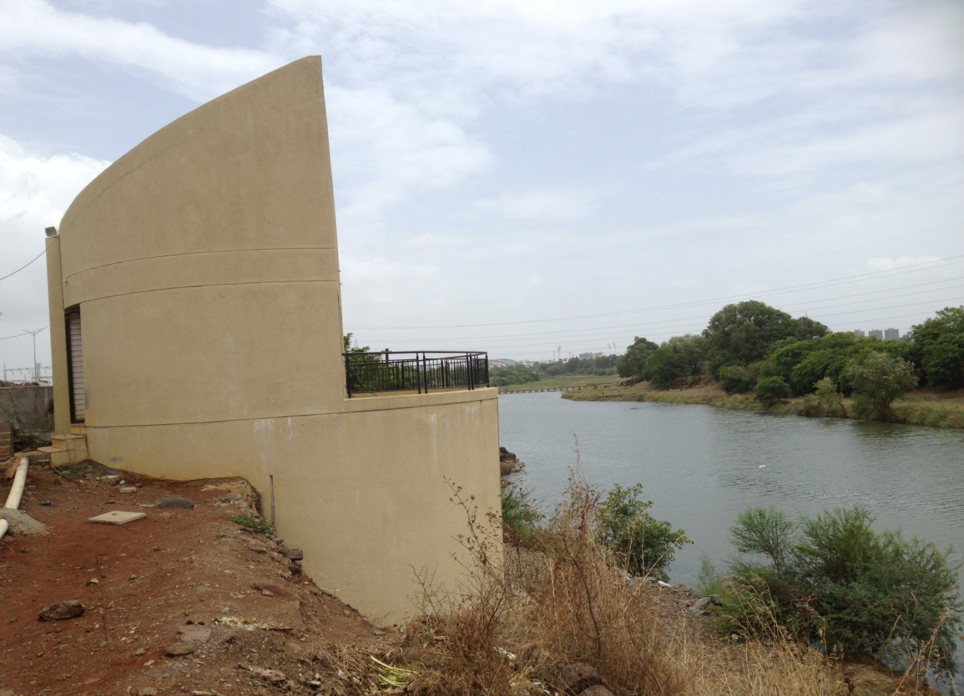

1. **IVY ESTATES WAGHOLI :**

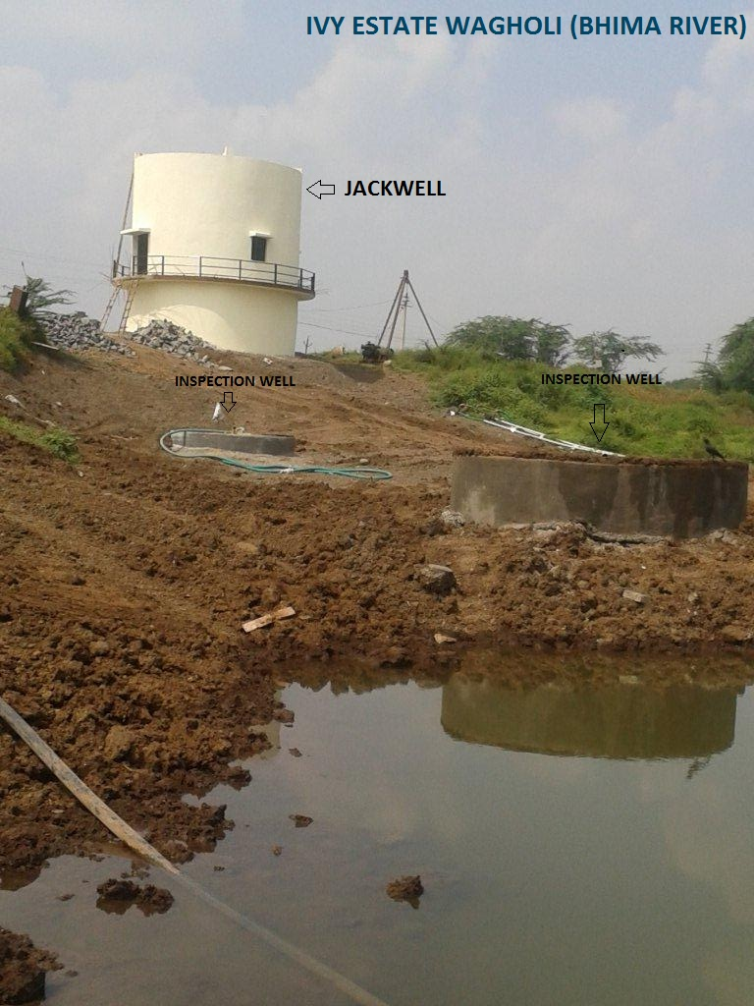

1. **ENERRGIA :**

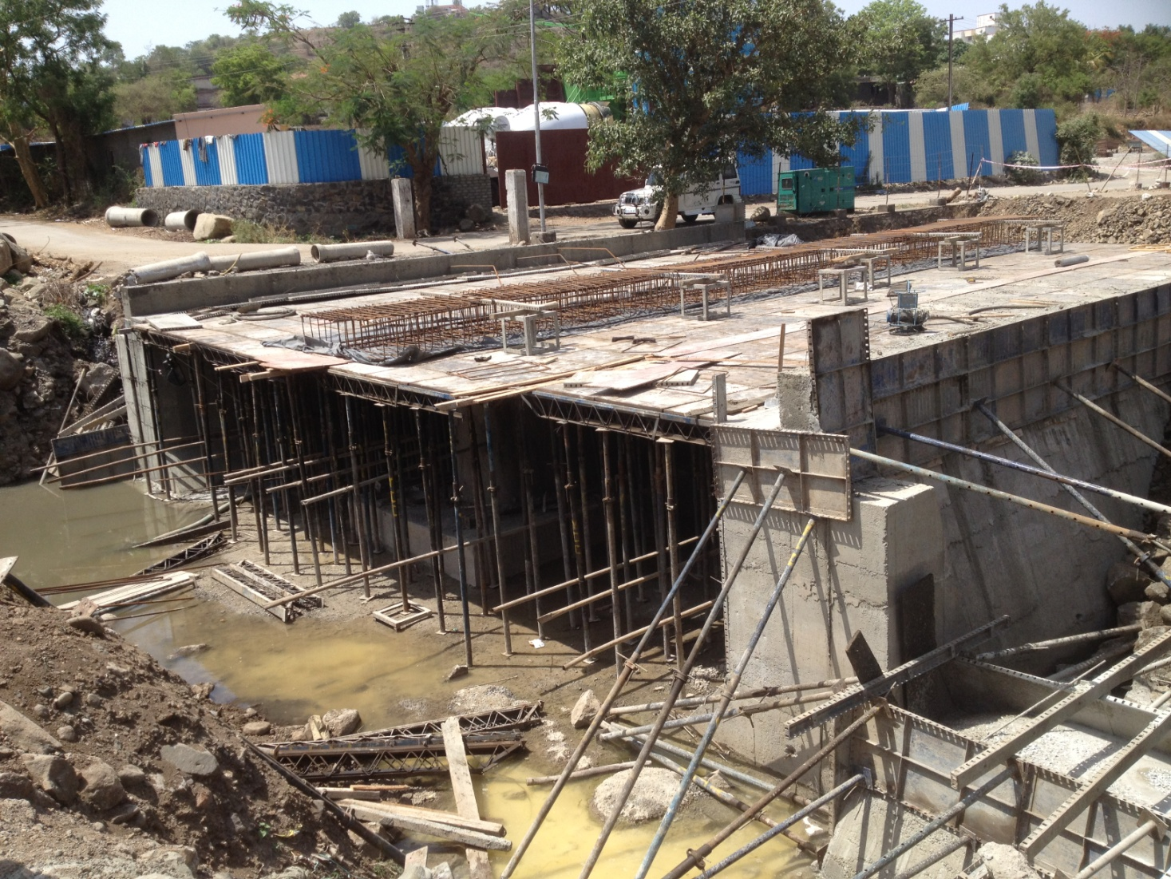

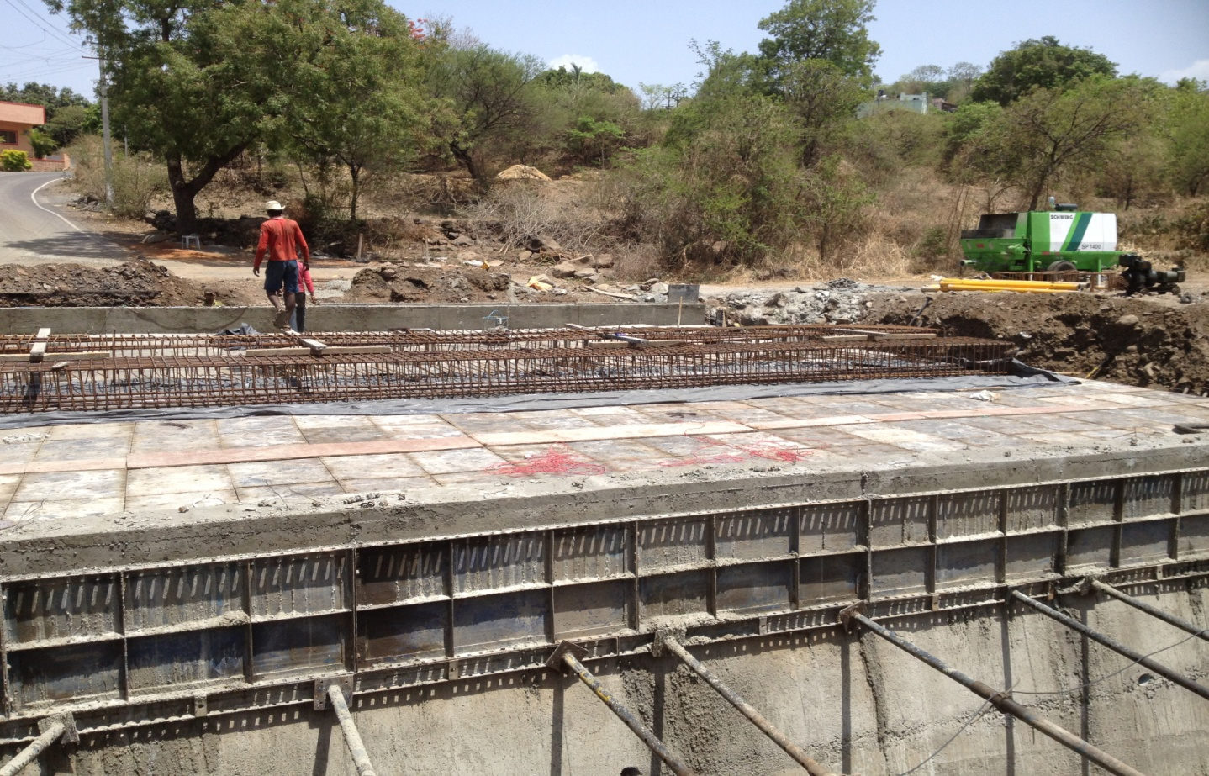

**4. WATER TREATMENT PLANT AT LODHA BELMONDO**

